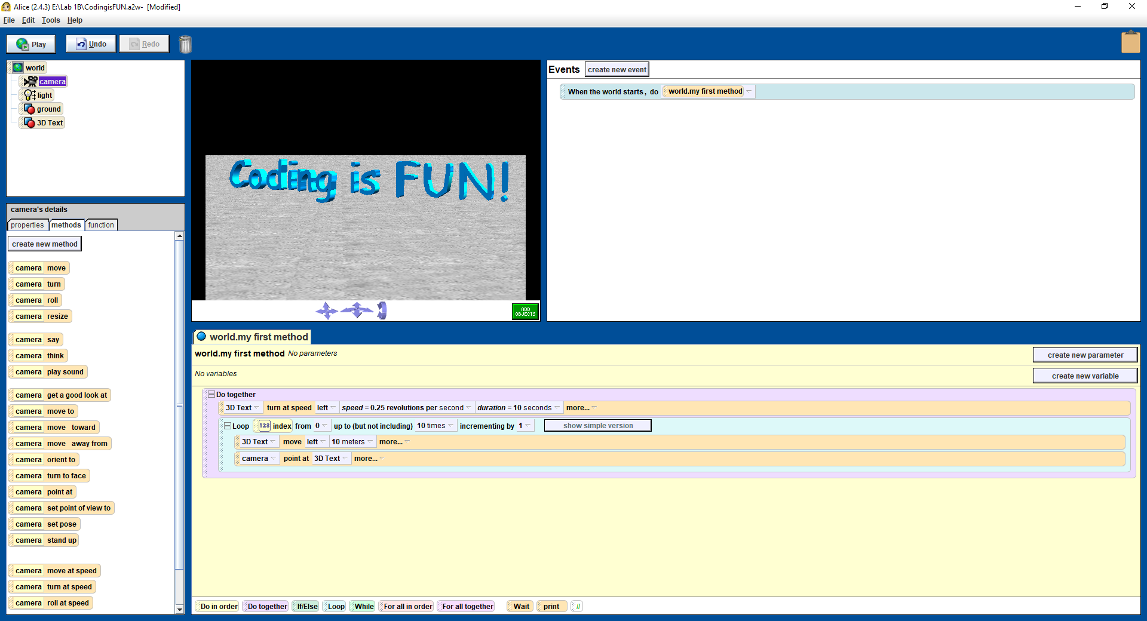
CASEY SORRELLS
LAB 1B
ALICE IDE SCREENSHOT

